Insert your name, centre number and candidate number into the header above.
Save this evidence document as evidence_ followed by your centre number_ candidate number. For example: evidence_ zz999_9999.doc
Screenshots or program listings must be copied into appropriate cells in the following tables.
Examiners must be able to read the contents including any screenshots without the use of a magnifying glass. Answers that are not readable or missing will not be awarded any marks.
Save this evidence document at regular intervals, for example every 10 minutes.
Question 1
Part 1(a)(i)
{Copy and paste program code listing for question 1(a)(i) here}

class BoardObject:
def __init__(self,c,v):
self.__Code=c # PRIVATE Code: STRING
self.__Value=v # PRIVATE Value: INTEGER

Part 1(a)(ii)
{Copy and paste program code listing for question 1(a)(ii) here}

def GetCode(self): return self.__Code
def GetValue(self): return self.__Value

Part 1(a)(iii)
{Copy and paste program code listing for question 1(a)(iii) here}

#main
Object1=BoardObject("A",2)
Object2=BoardObject("B",3)
Object3=BoardObject("C",5)
Object4=BoardObject("D",2)
Object5=BoardObject("E",7)

Part 1(b)(i)
{Copy and paste program code listing for question 1(b)(i) here}

class Board:
def __init__(self):
self.__TheBoard=[[BoardObject("-",0) for _ in range(10)] for _ in range(10)] # PRIVATE TheBoard: ARRAY[0:9,0:9] OF BoardObject

Part 1(b)(ii)
{Copy and paste program code listing for question 1(b)(ii) here}

def GetObject(self,r,c): return self.__TheBoard[r][c]

Part 1(b)(iii)
{Copy and paste program code listing for question 1(b)(iii) here}

def SetObject(self,Obj,r,c): self.__TheBoard[r][c]=Obj

Part 1(b)(iv)
{Copy and paste program code listing for question 1(b)(iv) here}

def DisplayBoard(self):
for row in self.__TheBoard:
for Obj in row:
print(Obj.GetCode(),end=" ")
print("")

Part 1(c)(i)
{Copy and paste program code listing for question 1(c)(i) here}

Board1=Board()
Board1.SetObject(Object1,0,0)
Board1.SetObject(Object2,9,9)
Board1.SetObject(Object3,4,5)
Board1.SetObject(Object4,2,2)
Board1.SetObject(Object5,8,7)
Board1.DisplayBoard()

Part 1(c)(ii)
{Copy and paste screenshot(s) for question 1(c)(ii) here}

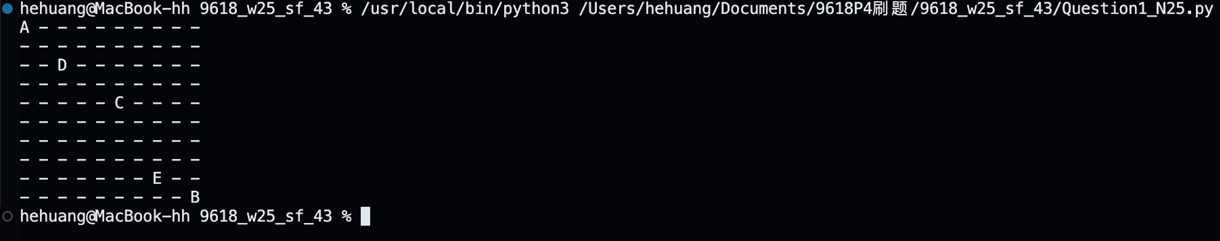

Part 1(d)(i)
{Copy and paste program code listing for question 1(d)(i) here}

InvalidRow=True
InvalidColumn=True
while InvalidRow:
Row=int(input("Enter a row position between 0 and 9 inclusive. "))
if Row>=0 and Row<=9: InvalidRow=False
else: print("Invalid row position.")
while InvalidColumn:
Column=int(input("Enter a column position between 0 and 9 inclusive. "))
if Column>=0 and Column<=9: InvalidColumn=False
else: print("Invalid column position.")

Object0=Board1.GetObject(Row,Column)
if Object0.GetCode()=="-": print("Miss")
else: print(f"Code: {Object0.GetCode()} Value: {Object0.GetValue()}")

Part 1(d)(ii)
{Copy and paste screenshot(s) for question 1(d)(ii) here}

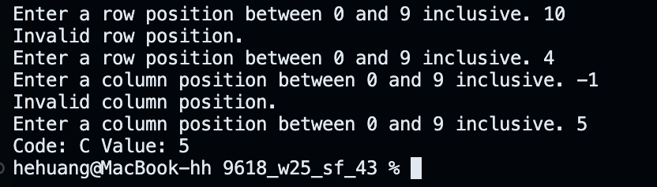

Question 2
Part 2(a)
{Copy and paste program code listing for question 2(a) here}

global Queue # DECLARE Queue: ARRAY[0:99] OF STRING
global QueueHead
global QueueTail
global NumberItems

#main
Queue=["" for _ in range(100)]
QueueHead=-1
QueueTail=-1
NumberItems=0

Part 2(b)
{Copy and paste program code listing for question 2(b) here}

def Enqueue(NewItem):
global Queue
global QueueHead
global QueueTail
global NumberItems

if NumberItems>=100:
return False

NumberItems+=1
QueueTail+=1
if QueueTail==0:
QueueHead=0
Queue[QueueTail]=NewItem
return True

Part 2(c)
{Copy and paste program code listing for question 2(c) here}

def Dequeue():
global Queue
global QueueHead
global QueueTail
global NumberItems

if NumberItems<1:
return "False"
NumberItems-=1
QueueHead+=1
return Queue[QueueHead-1]

Part 2(d)
{Copy and paste program code listing for question 2(d) here}

def ReadData():
try:
f=open("BinaryData.txt",'r')
for i in range(100):
x=f.readline().strip()
if x=="": break
else: Enqueue(x)

f.close()
except IOError:
print("File not found")

Part 2(e)
{Copy and paste program code listing for question 2(e) here}
global Queue # DECLARE Queue: ARRAY[0:99] OF STRING
global QueueHead
global QueueTail
global NumberItems
global NewString
def Compress():
global NewString
NewString=""
CurrentStr=""
StopDequeue=False
while not StopDequeue:
Current=Dequeue()
if Current=="False":
StopDequeue=True
NewString+=(CurrentStr[0]+str(len(CurrentStr)))
else:
if len(CurrentStr)==0:
CurrentStr+=Current
else:
if Current==CurrentStr[0]:
CurrentStr+=Current
else:
NewString+=(CurrentStr[0]+str(len(CurrentStr)))
CurrentStr=Current

Part 2(f)(i)
{Copy and paste program code listing for question 2(f)(i) here}

ReadData()
Compress()
print(NewString)

Part 2(f)(ii)
{Copy and paste screenshot(s) for question 2(f)(ii) here}

Question 3
Part 3(a)(i)
{Copy and paste program code listing for question 3(a)(i) here}

def RecursiveCount(ArrayCopy,NumberElements,DataTofind):
if NumberElements==0:
return 0
if ArrayCopy[0]==DataTofind:
return RecursiveCount(ArrayCopy[1:len(ArrayCopy)],NumberElements-1,DataTofind)+1
else:
return RecursiveCount(ArrayCopy[1:len(ArrayCopy)],NumberElements-1,DataTofind)

Part 3(a)(ii)
{Copy and paste program code listing for question 3(a)(ii) here}

#main
DataArr=[0,5,1,2,5,9,9,6,5,0]
print(RecursiveCount(DataArr,10,0))

Part 3(a)(iii)
{Copy and paste screenshot(s) for question 3(a)(iii) here}

Part 3(b)(i)
{Copy and paste program code listing for question 3(b)(i) here}

Processes="x=0;y=1;x=x+y;y++;"

Part 3(b)(ii)
{Copy and paste program code listing for question 3(b)(ii) here}

def SplitData(Data):
Process=[]
Task=""
for char in Data:
if char==";":
Process.append(Task)
Task=""
else:
Task+=char
return Process

Part 3(b)(iii)
{Copy and paste program code listing for question 3(b)(iii) here}

ProcessArr=SplitData(Processes)
for Statement in ProcessArr:
print(Statement)

Part 3(b)(iv)
{Copy and paste screenshot(s) for question 3(b)(iv) here}
